#include <stdio.h>

int main()

{

int day;

scanf("%d",&day);

switch(day) {

case 1 : //if (day==1)

printf("Boss! Its Monday , concentrate on \"work\"");

break;

case 2 ... 4 : // case 2 : case 3 : case 4:

printf("Still its week day only");

break;

case 5 :

printf(" Its Friday , get ready for weekend");

break;

case 6 : case 7 :

printf(" Enjoy the holiday");

break;

default :

printf("Invalid day");

}

return 0;

}

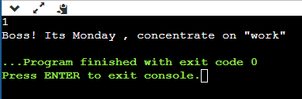

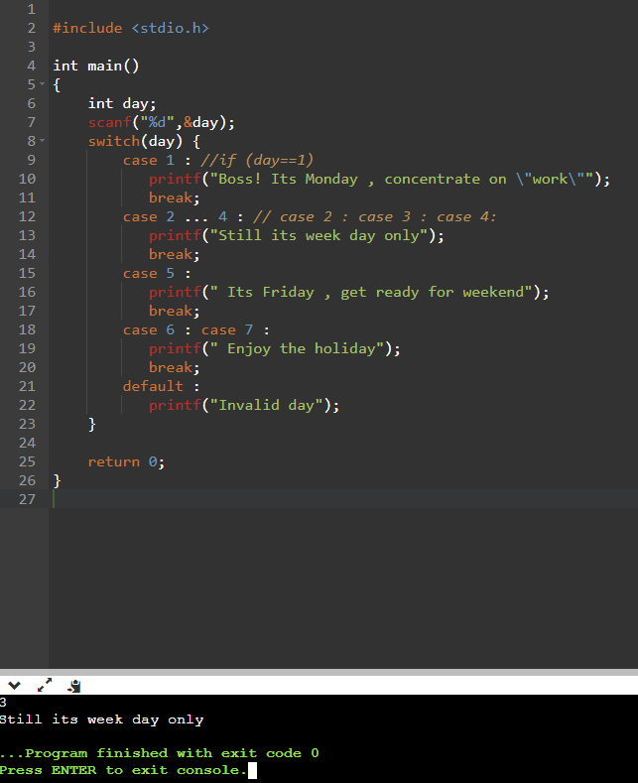

**// program to implement simple calculator**

#include <stdio.h>

#include <math.h>

int main()

{

double op1 , op2 , result;

char opr;

//getting an expression

scanf("%lf %c %lf",&op1,&opr,&op2); //input format is 10 + 20

switch(opr) {

case '+' :

result = op1 + op2;

break;

case '-' :

result = op1 - op2;

break;

case '/' :

result = op1 / op2;

break;

case '*' :

result = op1 * op2;

break;

case '%' :

result = fmod( op1 , op2); // % cannot be applied on float and double in c it m,ust be integer

break;

default :

printf(" Invalid operator");

return 0;

}

printf(" %g %c %g = %g", op1,opr,op2,result); //%g can be used only for double and float

return 0;

}

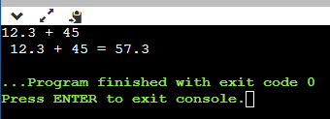

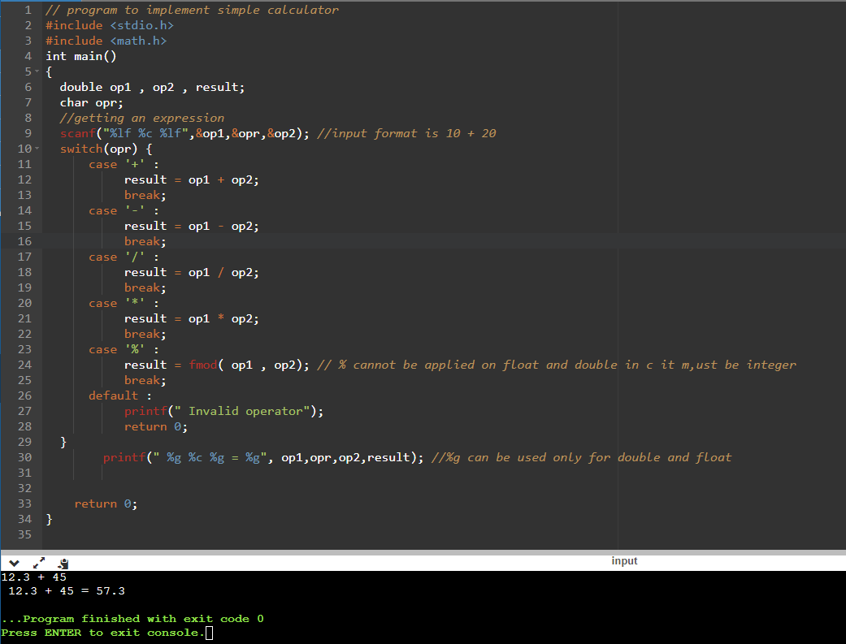

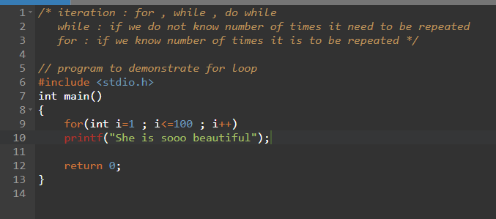

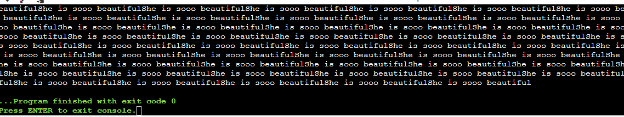

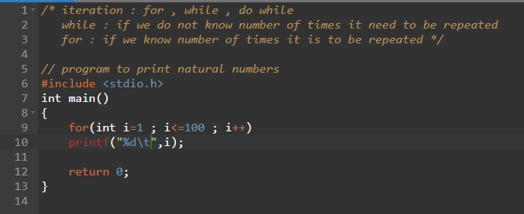

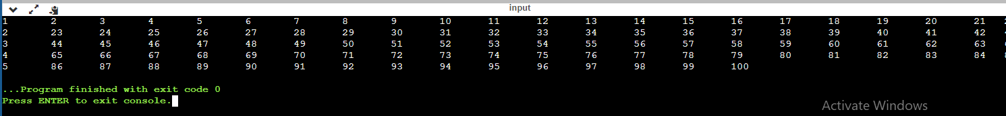

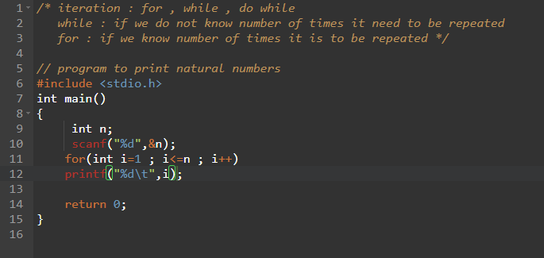



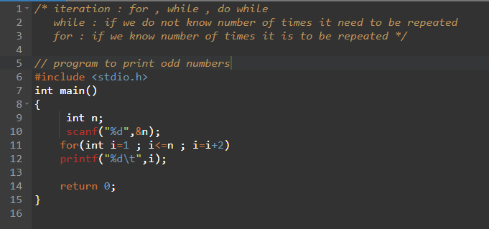

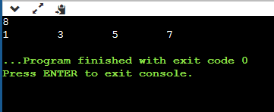

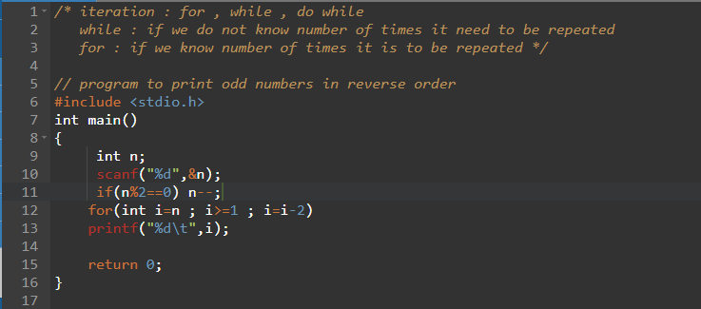

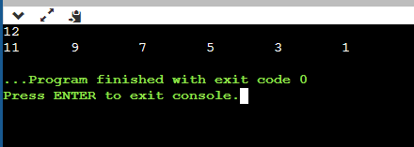

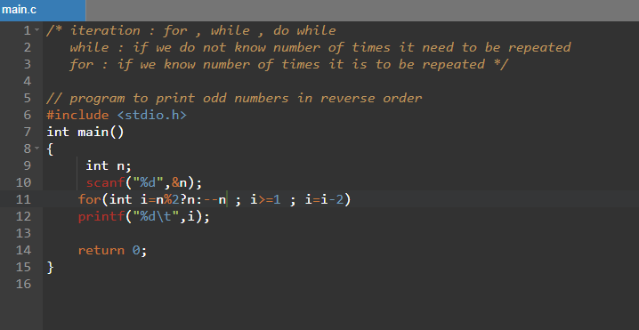

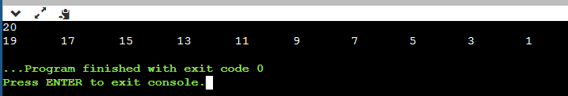

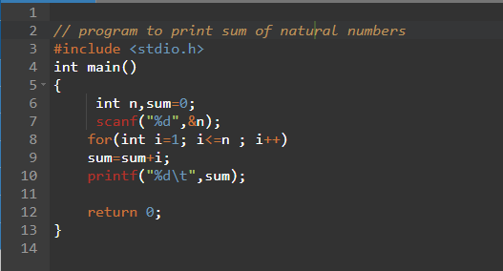

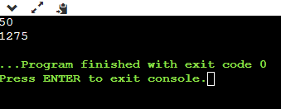

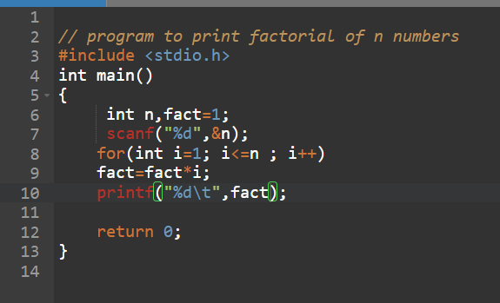

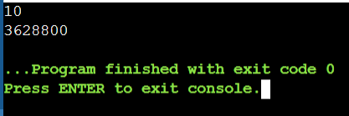

**// program to reverse a number**

#include <stdio.h>

int main()

{

int n, reverse=0 , remainder;

printf("Enter the number: ");

scanf("%d",&n);

while(n!=0){

remainder =n%10;

reverse = reverse*10+remainder;

n/=10;

}

printf("\n The reversed number : %d",reverse);

return 0;

}

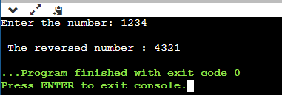

**// program to reverse a number and check palindrome**

#include <stdio.h>

int main()

{

int n, reverse=0 , remainder,original;

printf("Enter the number: ");

scanf("%d",&n);

original=n;

while(n!=0){

remainder =n%10;

reverse = reverse*10+remainder;

n/=10;

}

printf("\n The reversed number : %d",reverse);

if(original==reverse)

printf("\nThe given number is palindrome\n");

else

printf("The given number is not a palindrome\n");

return 0;

}

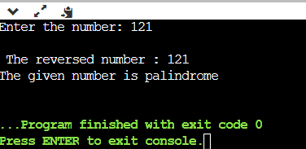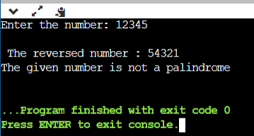

**// shorter code for reverse and palindrome**

#include <stdio.h>

int main()

{

int n, reverse=0 , remainder,original;

printf("Enter the number: ");

scanf("%d",&n);

original=n;

while(reverse = reverse*10+n%10, n/=10);

printf("%d\n",reverse);

printf("%s",original==reverse?"yes":"no");

return 0;

}

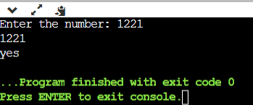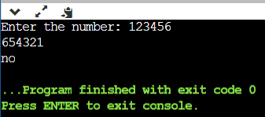

// program to check if given number is pos , neg or zero

#include <stdio.h>

int main()

{

int n;

printf("Enter a number :");

scanf("%d",&n);

if(n>0)

printf("%d is positive",n);

else if(n<0)

printf("%d is negative",n);

else

printf("it is zero");

return 0;

}

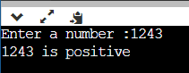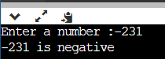

// program to demonstrate do... while statement

#include <stdio.h>

int main()

{

int n;

char option;

do{

printf("Enter a number :");

scanf("%d",&n);

if(n>0)

printf("%d is positive",n);

else if(n<0)

printf("%d is negative",n);

else

printf("it is zero");

printf("\nwant to check more [y]es/[n]o? ");

scanf("%c",&option);

scanf("%c",&option);

}while(option=='y'||option=='Y');

return 0;

}

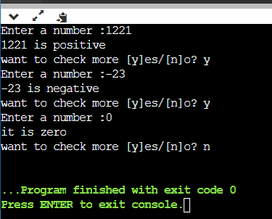

// always go with int main() instead of void main()

// program to demonstrate break statement

#include <stdio.h>

int main()

{

for(int i=1;i<=10;i++){

if(i%4)

break;//break means it comes out of for , printf statement won't execute

printf("%d",i);

}

return 0;

}

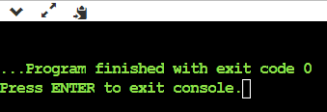

// program to demonstrate break statement

#include <stdio.h>

int main()

{

for(int i=1;i<=10;i++){

if(i%4==0)

break;

printf("%d",i);

}

return 0;

}

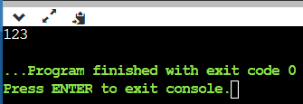

// program to demonstrate continue statement

//continue can be used inside looping only i.e for , while , do while

#include <stdio.h>

int main()

{

for(int i=1;i<=10;i++){

if(i%4==0)

continue;

printf("%d\t",i);

}

return 0;

}

// does not print 4 multiples

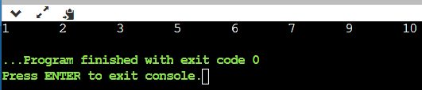

// program to demonstrate break statement

#include <stdio.h>

int main()

{

for(int j=1;j<=5;j++){

for(int i=1;i<=10;i++){

if(i%4==0)

break;

printf("%d",i);

}

}

return 0;

}

// break can be applied to only immediate loop, not outer loop

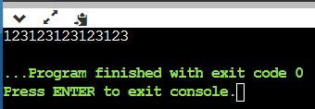

// program to demonstrate goto statement

//goto is unconditional control structure , avoid using goto

#include <stdio.h>

int main()

{

for(int j=1;j<=5;j++){

for(int i=1;i<=10;i++){

if(i%4==0)

goto exit;

printf("%d",i);

}

}

exit : //label

return 0;

}

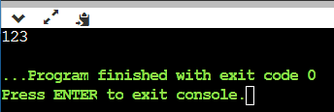

// program to demonstrate goto statement

//goto is unconditional control structure , avoid using goto

#include <stdio.h>

int main()

{

monisha :

printf(" Monisha is so pretty");

goto monisha;

return 0;

}

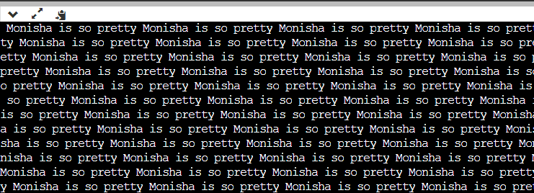

// so goto is unconditional control structure

// program to demonstrate nested loop

// without nested loop we cannot write pattern program

#include<stdio.h>

int main()

{

for(int i=1;i<=5;i++){ //row

for(int j=1;j<=5;j++){ //column

printf("Welcome\t");

}

}

return 0;

}

// welcome will be printed 5*5=25 times



// program to demonstrate nested loop

// without nested loop we cannot write pattern program

#include<stdio.h>

int main()

{

for(int i=1;i<=5;i++){ //row

for(int j=1;j<=5;j++){ //column

printf("Welcome\t");

}

printf("\n");

}

return 0;

}

// welcome will be printed 5*5=25 times

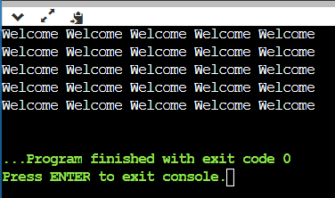

// program to demonstrate nested loop

// without nested loop we cannot write pattern program

#include<stdio.h>

int main()

{

for(int i=1;i<=5;i++){ //row- outer loop

for(int j=1;j<=i;j++){ //column- inne loop

printf("Welcome\t");

}

printf("\n");

}

return 0;

}

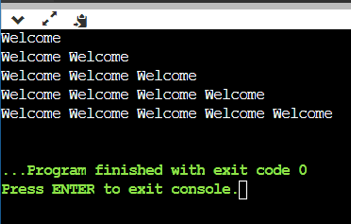

**// program to demonstrate nested loop**

// without nested loop we cannot write pattern program

#include<stdio.h>

int main()

{

for(int i=1;i<=5;i++){ //row- outer loop

for(int j=1;j<=i;j++){ //column- inne loop

printf("%d\t",j);

}

printf("\n");

}

return 0;

}

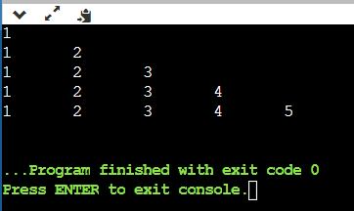

**// program to print pattern**

#include <stdio.h>

int main()

{

int n;

printf("Enter the number of rows:\n");

scanf("%d",&n);

for(int i=1;i<=n;i++){ //row- outer loop

for(int j=1;j<=i;j++){ //column- inne loop

printf("%d\t",j);

}

printf("\n");

}

return 0;

}

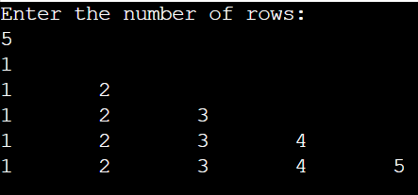

// program to print pattern

#include <stdio.h>

int main()

{

int n;

printf("Enter the number of rows:\n");

scanf("%d",&n);

for(int i=1;i<=n;i++){ //row- outer loop

for(int j=1;j<=n;j++){ //column- inne loop

printf("%d\t",j);

}

printf("\n");

}

return 0;

}

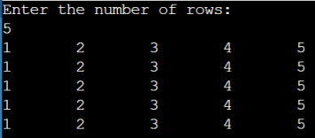

// program to print pattern

#include <stdio.h>

int main()

{

int n,i,j;

printf("Enter the number of rows:\n");

scanf("%d",&n);

for(int i=n;i>=1;i--){ //row- outer loop

for(int j=1;j<=i;j++){ //column- inne loop

printf("%d",j);

}

printf("\n");

}

return 0;

}

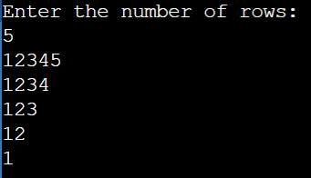

// program to print pattern

// here to print space and data we need a seperate loop

#include <stdio.h>

int main()

{

int n;

scanf("%d",&n);

for(int r=n;r>=1;r--){ //row- outer loop

// printing space

for(int c=1;c<=n-r;c++) // r=beginning or current rows , n= no of rows

printf(" ");

for(int c=r;c>=1;c--) // printing column

printf("%d",c);

printf("\n");

}

return 0;

}

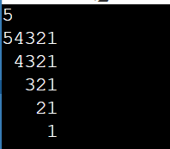

// program to print pattern

#include <stdio.h>

int main()

{

int n;

scanf("%d",&n);

for(int r=n;r>=1;r--){

for(int c=1;c<=r;c++)

printf("%d",c);

for(int c=1;c<=n-r;c++)

printf(" "); // here give double space

for(int c=r;c>=1;c--)

printf("%d",c);

printf("\n");

}

return 0;

}

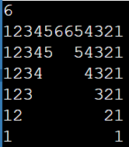

// program to print pattern

#include <stdio.h>

int main()

{

int n;

scanf("%d",&n);

for(int r=n;r>=1;r--){

for(int c=1;c<=r;c++)

printf("%d",c);

for(int c=1;c<=n-r;c++)

printf(" "); // here give single space

for(int c=r;c>=1;c--)

printf("%d",c);

printf("\n");

}

return 0;

}

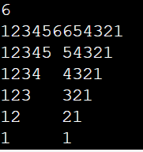

// program to print pattern

#include <stdio.h>

int main()

{

int n;

scanf("%d",&n);

for(int r=n;r>=1;r--){

for(int c=1;c<=r;c++)

printf("%d",c);

for(int c=1;c<=n-r;c++)

printf(" "); // here give double space

for(int c=r;c>=1;c--)

printf("*");

printf("\n");

}

return 0;

}

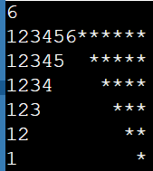

// program to print pattern

#include <stdio.h>

int main()

{

int n;

scanf("%d",&n);

for(int r=n;r>=1;r--){

for(int c=1;c<=r;c++)

// printf("%d",c);

printf("❤"); //to get symbol windoes symbol + fulllstop .

//printf(%c",c+64);

for(int c=1;c<=(n-r)*2;c++)

printf(" ");

for(int c=r;c>=1;c--)

// printf("%d",c);

printf("❤"); //to get symbol windoes symbol + fulllstop .

//printf(%c",c+64);

printf("\n");

}

return 0;

}

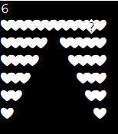

// program to print pattern

#include <stdio.h>

int main()

{

int n;

scanf("%d",&n);

for(int r=n;r>=1;r--){

for(int c=1;c<=r;c++)

// printf("%d",c);

//printf("❤"); //to get symbol windoes symbol + fulllstop .

printf("%c",c+64);

for(int c=1;c<=(n-r)*2;c++)

printf(" ");

for(int c=r;c>=1;c--)

// printf("%d",c);

//printf("❤"); //to get symbol windoes symbol + fulllstop .

printf("%c",c+64);

printf("\n");

}

return 0;

}

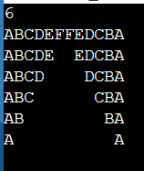

// program to print pattern

#include <stdio.h>

int main()

{

int n;

scanf("%d",&n);

for(int r=n;r>=1;r--){

for(int c=1;c<=r;c++)

printf("%d",c);

//printf("❤"); //to get symbol windoes symbol + fulllstop .

//printf("%c",c+64);

for(int c=1;c<=(n-r)*2;c++)

printf(" ");

for(int c=r;c>=1;c--)

printf("%d",c);

//printf("❤"); //to get symbol windoes symbol + fulllstop .

//printf("%c",c+64);

printf("\n");

}

return 0;

}

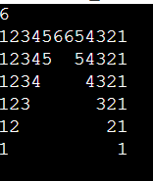

// program to print pattern

#include <stdio.h>

int main()

{

int n;

scanf("%d",&n);

for(int r=1;r<=n;r++){

for(int c=1;c<=n-r;c++)

printf(" ");

for(int c=1;c<=r*2-1;c++)

printf("*");

printf("\n");

}

return 0;

}

